Hello, I have been unsuccessful trying to use a macro in conjunction with Data Warrior’s built Evolutionary Library feature.
The current issue is that the evolutionary library appears to not allow pasting into the structures section (or smiles) when using a Macro. The Macro instead just takes a snapshot of what the Evolutionary library looked like at the end.
This can be shown here where there are three structures that were taken from putting the original oestradiol compound and putting it through the evolutionary library, taking the highest fitness, putting it through the evolutionary library two more times:

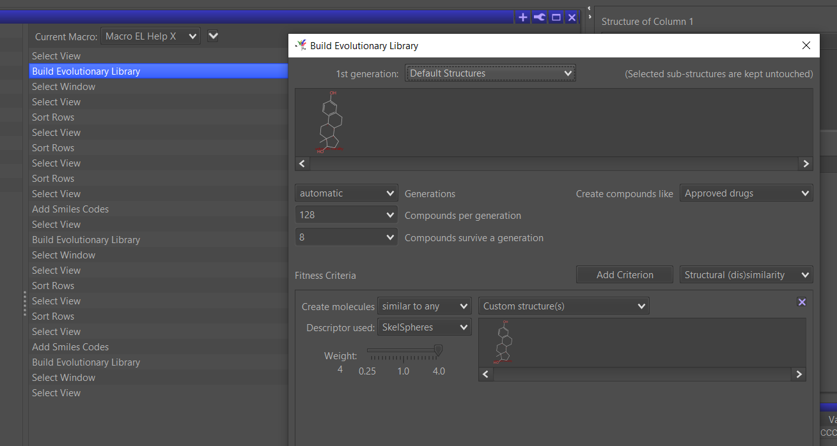
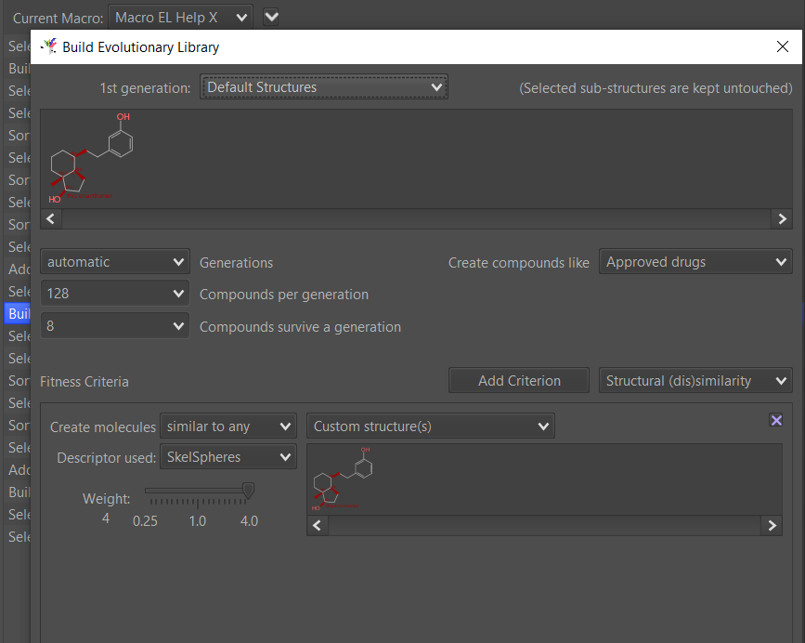
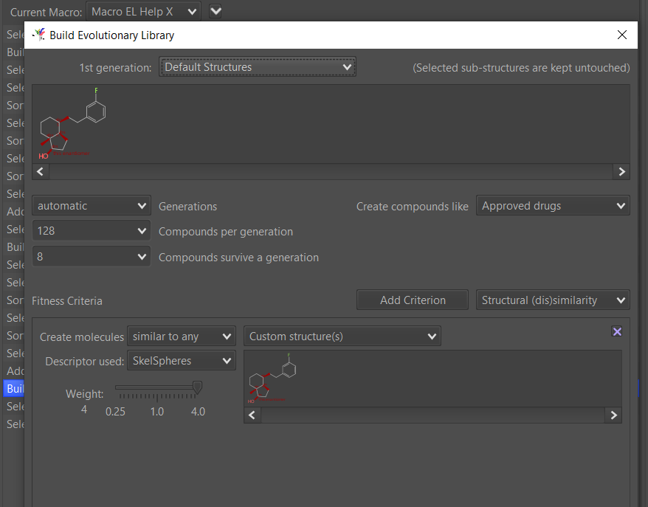

And yet, once the Macro was finished, and the evolutionary library was opened up you can see that it didn’t use the newly ‘evolved’ compounds:
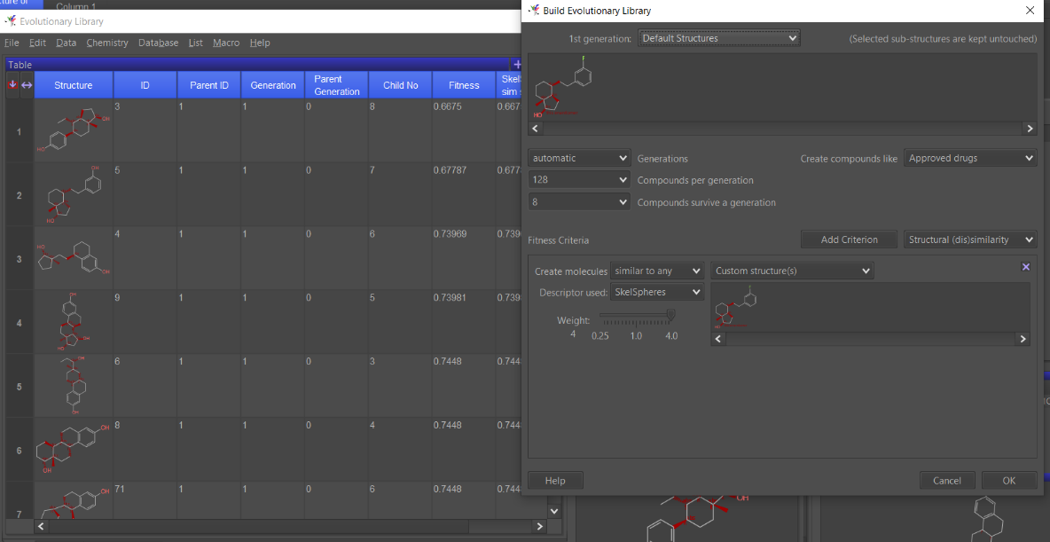
Is there any way to record pasting into the evolutionary library for a macro?
I know that I could adjust the EL setting to create many more structures but I want to try and do the above specifically by creating a a macro.
Many thanks in advance

