Problem with confirming Sali Calculated value in Datawarrior (DW)
A Sali prediction was undertaken in DW for a group of compounds imported via DW from chembl and filtered to contain only IC50 values (some of which had several IC50 values for the same molecule , however DW appears to just select the value at the top of the cell, rather than the average value ot the highest value and use this in the Sali prediction) and gave the following details:
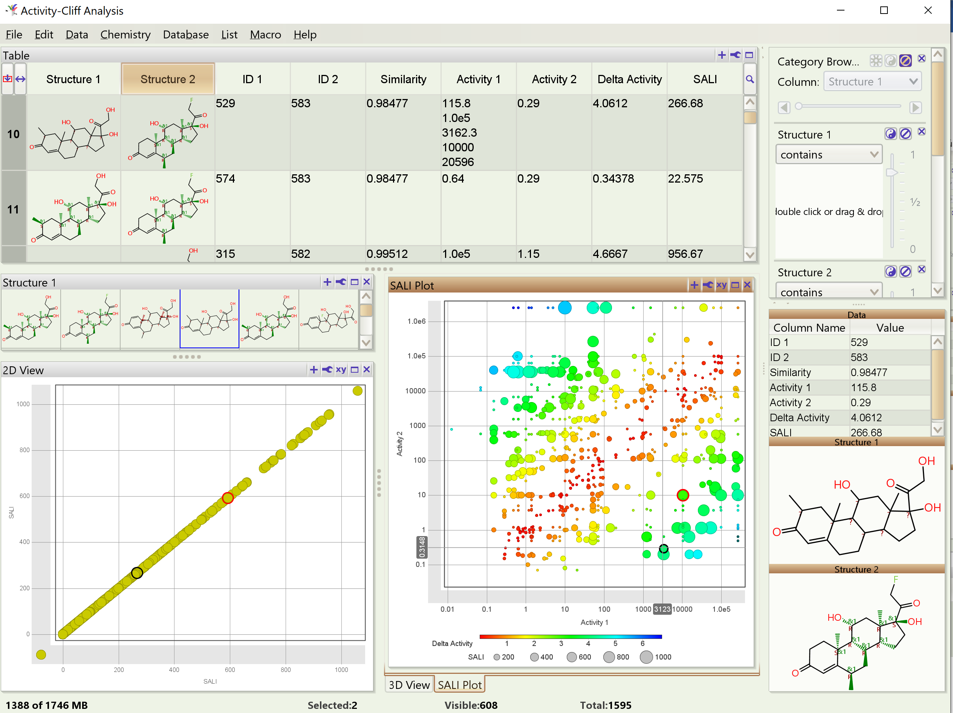
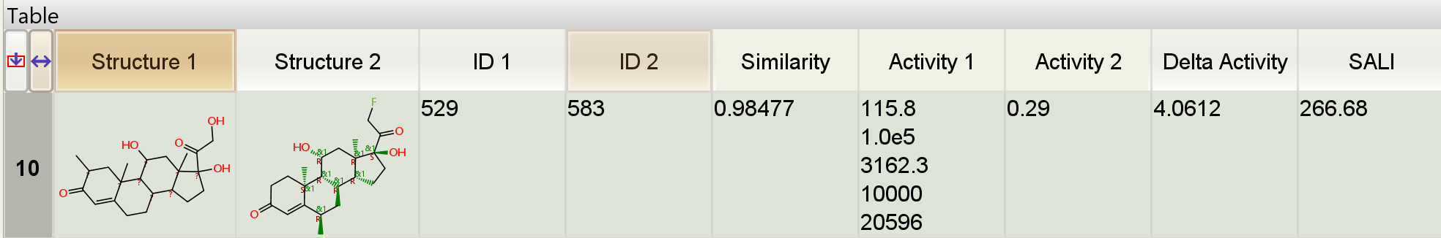
A Sali calculation was undertaken to confirm what DW predicted using the following equation:
(which the DW manual appears to confirm that this is the approach taken) : 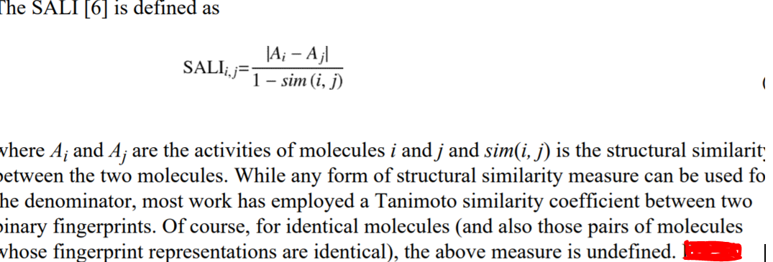

So calulating the Sali values from the figures in DW:
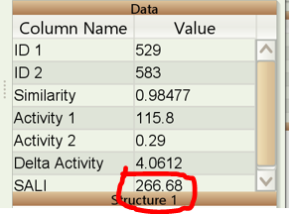
115.8 – 0.29 = 115.51;
1- 0.98477 = 0.01523;
115.51/ 0.01523 = 7,584.4 Sali value
But the Sali value was predicted to be 266.68 in Datawarrior (see the above snapshot)
- Could you kindly explain the discrepancy?

- Also what does the delta value mean and how is it calculated?

- A non chemist friend who is a mathematician had a look at the sali figures in DW and made the following comments :
“The DW software shows activity 1 and activity 2 as unchanged values but seems to show the activity delta as delta activty = log(activity 1) - log (activty 2), the sali is then calculated as sali = delta activity / (1 - similarity).
It is not obvious how to configure the software to be consistent with the activity values and their delta values”

I don’t know if this is of any help?

- Is it only possible to perform activity cliffs with one descriptor?

E.g SphereFp or SkeletonSpheres

It seems that using one descriptor is now considered a poor model for predicting biological activity in general – e.g using LogKOW plus say LD50 values to predict the unknown LD50 values of similar chemicals within an the applicability domain.

So can you use multi descriptors in DW for Sali plots? If so how do you do this?

Or is it that the descriptors in DW such SphereFp, SkeletonSpheres, PathFp descriptor, OrgFunctions descriptor, and Flexophore are actually an amalgamation of many descriptors and should therefore be consider multi descriptors?

Also adding to the last question – with the machine learning tool in DW and “predicting missing values” – again this looks like you can only use one descriptor – in DW is that true or is there a ”work around”. If not, is there plans to be able to use multiple descriptors for machine learning and Sali plots in DW in the near future?

Could you answer, if possible the above questions point by point
Many thanks in advance

